Instructions to Run file:

1. Download the necessary starter kit and data files. Data should be kept under the folder named “data” for the following path to work :

imgs_path = './data/hw3_mycocodata_img_comp_zlib.h5'

masks_path = './data/hw3_mycocodata_mask_comp_zlib.h5'

labels_path = './data/hw3_mycocodata_labels_comp_zlib.npy'

bboxes_path = './data/hw3_mycocodata_bboxes_comp_zlib.npy'

1. Create a folder named “testfig” initially in the working directory to save plots after running the file.
2. Run dataset.py as it is completely. It will show the necessary plots (Visualization 5 and 6)

**Results of Visualization 5 and 6:**

Plots for different classes with masks applied –

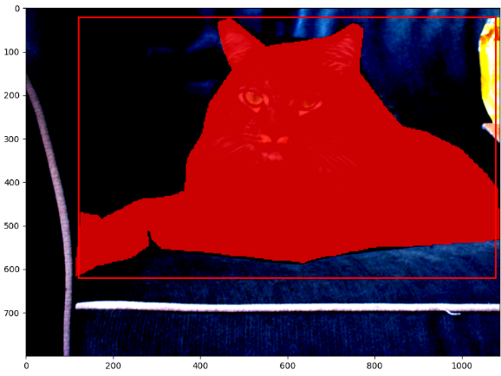 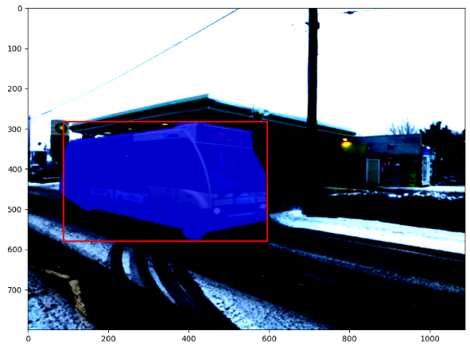

Red class Blue Class

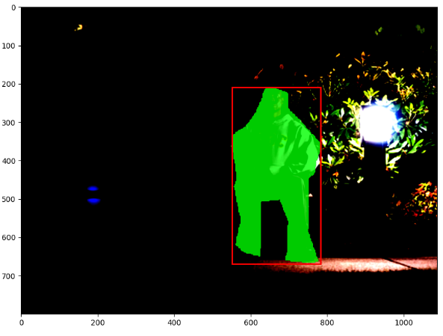 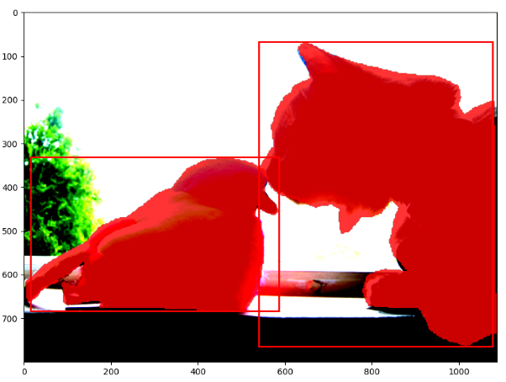

Green class Masks are consistent in presence of multiple objects

**Plots containing multiple objects of different classes, with masks applied –**

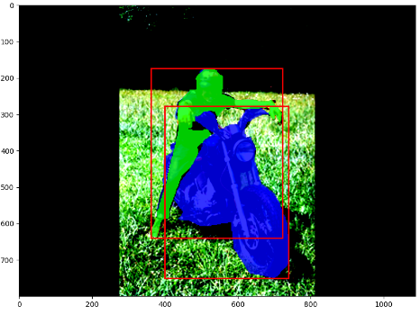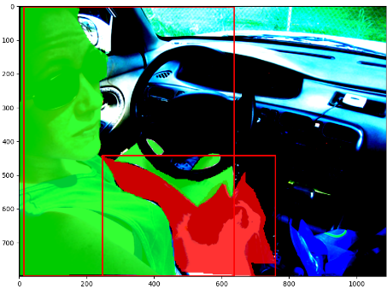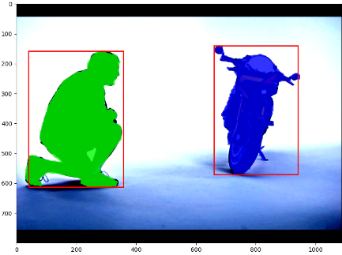

Image containing multiple objects are masked based on their class labels

1. For Visualization of target assignments, we are sharing our colab notebook in which we defined architecture, initialized weights, generated targets and visualized the targets across different scales of FPN. The notebook needs to be run sequentially and the plots will be generated without any errors. There is a minor problem that the visualizations don’t have coloured masks. We tried to debug it but ran out of time.

**Plots of target assignments:**

